Standing Waves in a String
w/ Mech. Wave Driver and Sine Wave Generator

Equipment Needed

Clamp, Table Black H21160
Clamp, Table Bu/Bk w/ Adjustable Pulley
Tape Measure, 5m Stanley 33-158
Mass Hanger, 50 g
Mass Set, Gram Assorted
Mech. Wave Driver w/ Cord Pasco SF-9324
Lead, Banana/Banana Bu&Y
Sine Wave Generator Pasco WA-986
AC/DC Power Supply Condor HK-B524-A15
String Vibrator Accessories,
Wood Blocks
2m Braided Physics String Pasco SE-8050
Wedge
Scale, Digital Sartorious BP-6100

Basic Setup
Figure 1A
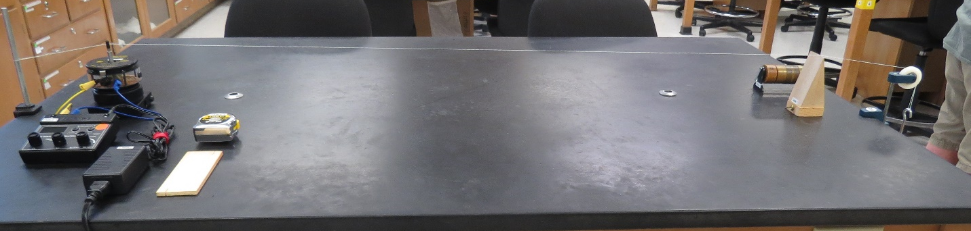
Figure 1B Figure 1C
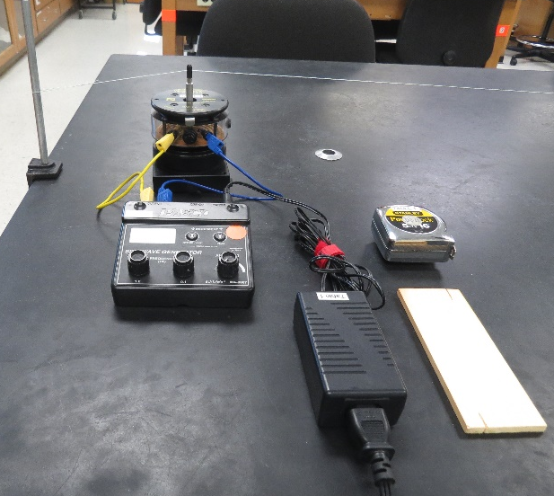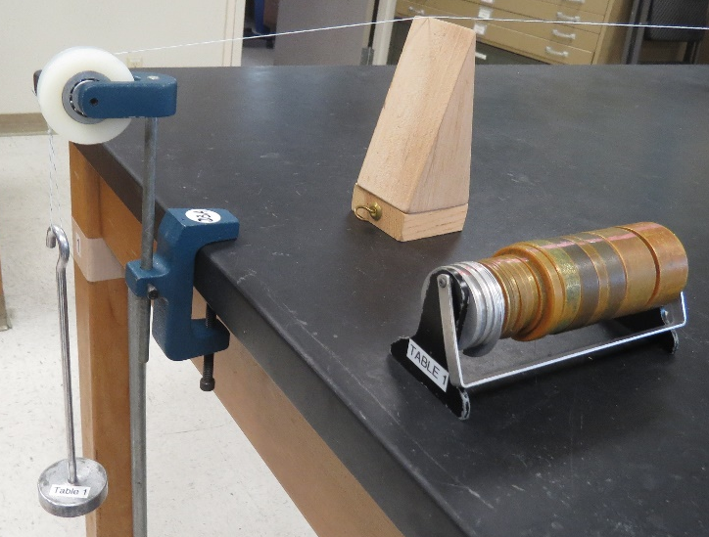

Theory
A wave travels down a string with a velocity:
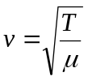 Equation 1
Figure 1
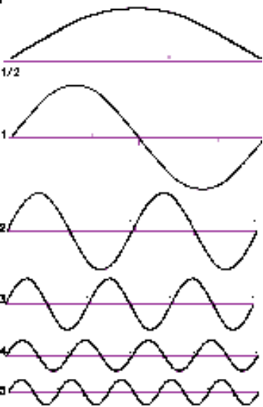where
T is tension and
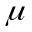 is the linear density in mass of the string per unit length
where
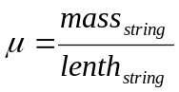 Equation 2
The wave reflects from a rigid end and travels back. If the string is an integral number of half wavelengths long, the string will resonate and display this number of 1/2-waves as in Figure 1. The wavelength is:
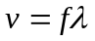 Equation 3
If we combine Equation 1 and Equation 3 we get
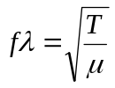 Equation 4
Solving Equation 4 for f we get
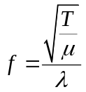 Equation 5
We are using the Braided Physics string in the accessory box. It has been determined through a special procedure that
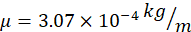
Values for of the three media are included in the baggy.
Figure 2 shows a typical half-wave. Figure 3 shows an actual photograph of the same half-wave.

Figure 2
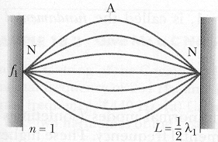
Figure 3
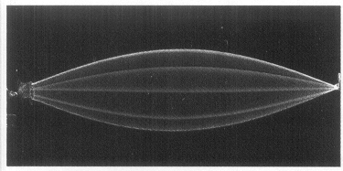
Figures 4 and 5 show a full wave.
Figure 4
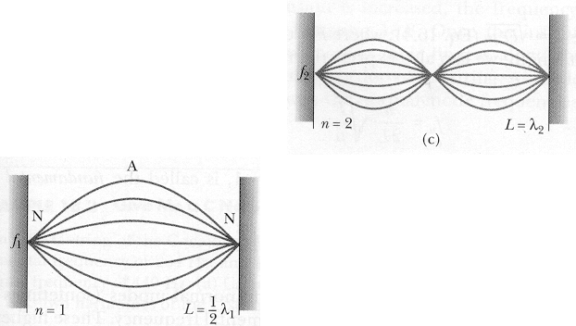
Figure 5
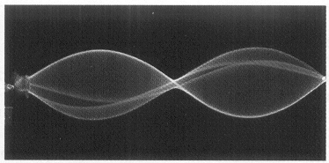
Figure 6 and 7 demonstrate 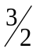 wavelengths.
Figure 6
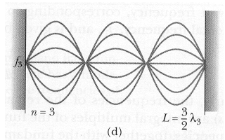
Figure 7
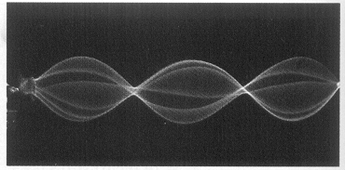

Basic Lab Set-up
- Figure 1B shows how to use the Mechanical wave Driver with the Humboldt clamp. You may need to fine tune the angle the string makes. Tape the string to the clamp if necessary.
- Figure 1A shows an overall layout for the experiment.
- Figure 1C shows the pulley and weight arrangement at the other end of the string.

Procedure No. 1—Resonance with Varying Frequency
This portion finds different resonant frequencies f and compares them with the known frequencies while L (length of string) and T (tension on the string) remain unchanged.
- To get frequency resonance:
  - For Tension T: Place 100 grams on the mass hanger (for a total of 150 g.) Weigh it on the electronic scales. Do the calculations for tension T. It will not change.
  - For length of string L: Measure L—the distance from the mechanical wave driver to the center point on the pulley. Enter in the data table. It will not change.
  - For frequency f—this will be your changing value in Data Table 1.
    - Set the sine wave generator frequency at 60 Hz.
    - Start the sine wave generator amplitude at zero and slowly bring it up until you can see a visible wave in the string. It should never need to reach maximum amplitude.
    - Increase the frequency until you can get the string to resonate with stability. You should be able to get a wave form in the string similar to the illustration in Figures 3, 5, or 7. The tighter the nodes the better your wave is resonating.
- Find three calculated data points of resonant frequency if you can and enter in your table. Compare to the value that the generator shows.
Table 1
Hanging  Mass M  (kg) | Tension  (kgm/sec²) | n  anti-nodes | L  This value will be constant. | (m) | Velocity  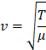  (m/s) | (Hz) | f  generator | %  difference
0.150
0.150
0.150

Procedure No. 2—Resonance with Varying Length of string
This portion finds calculated resonant frequency f and compares it with the known unchanging frequency while L (length of string) is changing and T (tension on the string) remains unchanged.
- To get frequency resonance:
  - For Tension T: Place 100 grams on the mass hanger (for a total of 150 g.) Weigh it on the electronic scales. Do the calculations for tension T. It will not change.
  - For frequency f—this will be constant under f generator in Data Table 2.
    - Set the sine wave generator frequency at 100 Hz. It will not change.
    - Start the sine wave generator amplitude at zero and slowly bring it up until you can see a visible wave in the string. It should never need to reach maximum amplitude.
  - For changing length of string L: Refer to Figure 1C. You will start with the wood block near the pulley. It will be moved toward the mechanical wave driver to achieve resonance. Measure L—the distance from the mechanical wave driver to the wood block. It will be changing. You should be able to get a wave form in the string similar to the illustration in Figures 3, 5, or 7. The tighter the nodes the better your wave is resonating.
- Find three calculated data points of resonant frequency if you can and enter in your table.
- Compare to the unchanging generator frequency f.
Table 2
Hanging  Mass M  (kg) | Tension  (kgm/sec²) | N  anti-nodes | L  This value will be changing. | (m) | Velocity  (m/s) | (Hz) | f  generator  This value will not change. | %  difference
0.150 |  |  |  |  |  |  | 100
0.150 |  |  |  |  |  |  | 100
0.150 |  |  |  |  |  |  | 100

Procedure No. 3—Resonance with Varying String Tension (Optional)
This portion finds calculates resonant frequency f and compares it with the known unchanging frequency while L (length of string) is not changing and T (tension on the string) is changing.
- To get frequency resonance:
  - For length of string L: Measure L—the distance from the mechanical wave driver to the center point on the pulley. Enter in the data table. It will not change.
  - For frequency f—this will be constant under f generator in Data Table 3.
    - Set the sine wave generator frequency at 100 Hz. It will not change.
    - Start the sine wave generator amplitude at zero and slowly bring it up until you can see a visible wave in the string. It should never need to reach maximum amplitude.
  - For changing Tension T: Place 50 grams on the mass hanger (for a total of 100 g.)
    - Increase the mass until you are able to get a wave form in the string similar to the illustration in Figures 3, 5, or 7. The tighter the nodes the better your wave is resonating.
    - By increasing the mass you should be able to find two or three more data points.
- Find three calculated data points of resonant frequency if you can and enter in your table.
- Compare to the unchanging generator frequency f.
Table 3
Hanging  Mass M  (kg)This value will change. | Tension  (kgm/sec²) | n  anti-nodes | L  This value will not change | (m) | Velocity  (m/s) | (Hz) | f  generator  This value will not change. | %  difference
 |  |  |  |  |  |  | 100
 |  |  |  |  |  |  | 100
 |  |  |  |  |  |  | 100

